

Semester Two Examination, 2016

Question/Answer Booklet

MATHEMATICS

SOLUTIONS
METHODS
UNITS 3 AND 4

Section One:

Calculator-free

Student Number: In figures

In words

Your name

Time allowed for this section
Reading time before commencing work: five minutes
Working time for section: fifty minutes

Materials required/recommended for this section
To be provided by the supervisor
This Question/Answer Booklet
Formula Sheet

To be provided by the candidate
Standard items: pens (blue/black preferred), pencils (including coloured), sharpener, correction fluid/tape, eraser, ruler, highlighters

Special items: nil

Important note to candidates
No other items may be taken into the examination room. It is your responsibility to ensure that you do not have any unauthorised notes or other items of a non-personal nature in the examination room. If you have any unauthorised material with you, hand it to the supervisor before reading any further.

Structure of this paper

Section | Number of questions available | Number of questions to be answered | Working  time (minutes) | Marks available | Percentage of exam
Section One:  Calculator-free | 7 | 7 | 50 | 52 | 35
Section Two:  Calculator-assumed | 13 | 13 | 100 | 98 | 65
 |  |  | Total | 150 | 100

Instructions to candidates

1. The rules for the conduct of examinations are detailed in the school handbook. Sitting this examination implies that you agree to abide by these rules.

2. Write your answers in this Question/Answer Booklet.

3. You must be careful to confine your response to the specific question asked and to follow any instructions that are specified to a particular question.

4. Spare pages are included at the end of this booklet. They can be used for planning your responses and/or as additional space if required to continue an answer.
- Planning: If you use the spare pages for planning, indicate this clearly at the top of the page.
- Continuing an answer: If you need to use the space to continue an answer, indicate in the original answer space where the answer is continued, i.e. give the page number. Fill in the number of the question that you are continuing to answer at the top of the page.

5. Show all your working clearly. Your working should be in sufficient detail to allow your answers to be checked readily and for marks to be awarded for reasoning. Incorrect answers given without supporting reasoning cannot be allocated any marks. For any question or part question worth more than two marks, valid working or justification is required to receive full marks. If you repeat any question, ensure that you cancel the answer you do not wish to have marked.

6. It is recommended that you do not use pencil, except in diagrams.

7. The Formula Sheet is not to be handed in with your Question/Booklet.

Section One: Calculator-free 35% (52 Marks)
This section has seven (7) questions. Answer all questions. Write your answers in the spaces provided.

Working time for this section is 50 minutes.

Question 1 (6 marks)
A particle leaves the origin when $t=1$ and moves in a straight line with velocity at any time $t$ seconds, where $t≥1$, given by
$$v\left(t\right)=\frac{t^{2}}{4}+\frac{4}{t}-\frac{7}{4} {\text{ms}}^{-1}$$

(a) Determine the time when the acceleration of the particle is zero. (2 marks)
Solution
$$a\left(t\right)=\frac{dv}{dt}=\frac{t}{2}-\frac{4}{t^{2}}$$
$$\frac{t}{2}-\frac{4}{t^{2}}=0⇒t^{3}=8⇒t=2 \text{s}$$

Specific behaviours
differentiates velocity
solves acceleration equal to zero

(b) Determine the exact displacement of the particle from the origin when $t=4$. (4 marks)

Solution
$$x\left(t\right)=\int{v(t)}dt=\frac{t^{3}}{12}+4ln{t}-\frac{7t}{4}+c \\ x\left(1\right)=0⇒\frac{1}{12}+0-\frac{7}{4}+c=0⇒c=\frac{5}{3} \\ x\left(4\right)=\frac{4^{3}}{12}+4\ln{4-\frac{7×4}{4}+\frac{5}{3}}=4\ln{4} \text{m}$$

Specific behaviours
integrates velocity
evaluates constant
substitutes time
determines position

Question 2 (7 marks)
(a) Calculate $f'(0)$ when $f\left(x\right)=e^{2x}{\left(1+5x\right)}^{3}$. (3 marks)

Solution
$$f^{'}\left(x\right)=2e^{2x}×{\left(1+5x\right)}^{3}+e^{2x}×3\left(5\right){\left(1+5x\right)}^{2} \\ f^{'}\left(0\right)=2×1+1×15=17$$

Specific behaviours
uses product rule and obtains $u'v$ correctly
uses chain rule and obtains $uv'$ correctly
substitutes to determine $f'(0)$

(b) Determine $\frac{d}{dx}\int_{x}^{5}{\sqrt{t^{2}+1}}dt$. (2 marks)

Solution
$$y=-\int_{5}^{x}{\sqrt{t^{2}+1}}dt \\ \frac{dy}{dx}=-\sqrt{x^{2}+1}$$

Specific behaviours
swaps limits correctly
differentiates

(c) Given $f^{'}\left(x\right)={\left(1-2x\right)}^{4}$ and $f\left(1\right)=-1$, determine $f(x)$. (2 marks)

Solution
$$f\left(x\right)=\frac{{\left(1-2x\right)}^{5}}{\left(-2\right)\left(5\right)}+c \\ f\left(1\right)=\frac{1}{10}+c=-1⇒c=-\frac{11}{10} \\ f\left(x\right)=-\frac{{\left(1-2x\right)}^{5}}{10}-\frac{11}{10}$$

Specific behaviours
antidifferentiates
evaluates constant and writes complete function

Question 3 (7 marks)
(a) The function $f$ is defined by $f\left(x\right)=\log_{a}{x}$, $x>0$, where $a$ is a constant, $a>1$.

The graphs shown below have equations $y=f\left(x\right)$, $y=f(x+b)$ and $y=f\left(x\right)+c$, where $b$ and $c$ are constants.
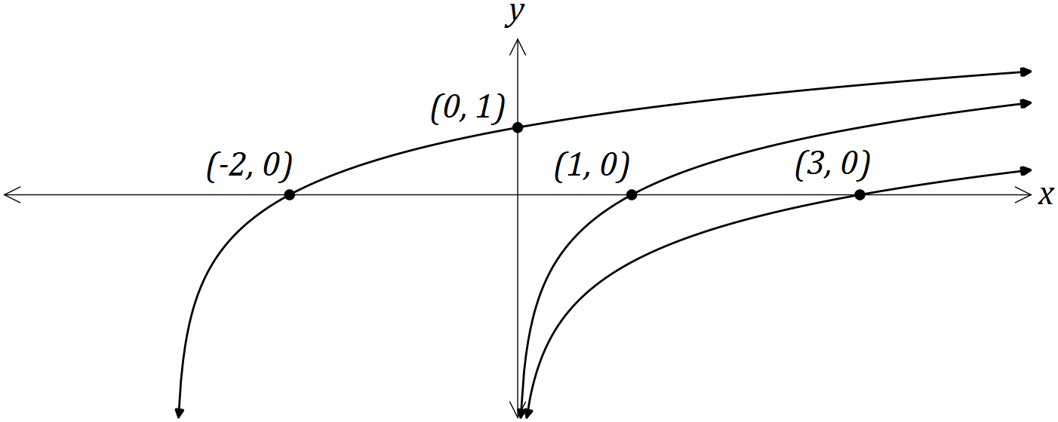

Determine the values of the constants $a$, $b$ and $c$. (4 marks)
Solution
$f\left(x+b\right)$ is only function that could pass through $\left(-2, 0\right)$.

Hence $0=f(-2+b)$ and so $b=3$.

Using $(0, 1)$, $1=\log_{a}{(0+3)}⇒a=3$

$\log_{3}{1}=0$ and so $f\left(x\right)$ must pass through $\left(1, 0\right)$

$f\left(x\right)+c$ passes through $\left(3, 0\right)⇒0=\log_{3}{3}+c=0$ and so $c=-1$

Specific behaviours
starts by using $f(x+b)$ and $(-2, 0)$
determines $b$
determines $a$
determines $c$

(b) Determine

(i) the equation of the asymptote of the graph of $y=\log_{e}\left(x-3\right)-2$. (1 mark)
Solution
$$x=3$$

Specific behaviours
writes asymptote as equation

(ii) the coordinates of the $y$-intercept of the graph of $y=\log_{2}{(x+8)}-5$. (2 marks)
Solution
$$\log_{2}{(8)}-5=3\log_{2}{2}-5=-2$$
$$\text{At} (0, -2)$$

Specific behaviours
substitutes and simplifies
writes using coordinates

Question 4 (8 marks)
A curve has equation $y=2x^{5}-5x^{4}+10$.

(a) Point A lies on the curve at ($-1, 3)$. Use the increments formula $δy≈\frac{dy}{dx}×δx$ to estimate the $y$-coordinate of point $B$ that has an $x$-coordinate of $-0.99$.
(4 marks)
Solution
$$\frac{dy}{dx}=10x^{4}-20x^{3} \\ x=-1⇒\frac{dy}{dx}=10+20=30 \\ δy≈30×0.01≈0.3 \\ \text{Estimate for }\text{y}\text{-}\text{coord}\text{ is }3+0.3=3.3$$

Specific behaviours
differentiates
substitutes to get gradient
finds change in y using increments
states new y-coordinate

(b) Point C also lies on the curve, at $(2, -6)$. Verify that C is either a minimum or maximum point of the curve. (4 marks)
Solution
$$x=2⇒\frac{dy}{dx}=160-160=0$$
$$\text{Hence }\text{C}\text{ is a stationary point as }\frac{dy}{dx}=0$$

$$\frac{d^{2}y}{dx^{2}}=40x^{3}-60x^{2}$$
$$x=2⇒\frac{d^{2}y}{dx^{2}}=320-240=80$$
$$\text{Hence }\text{C}\text{ is a minimum, as }\frac{d^{2}y}{dx^{2}}>0$$

Specific behaviours
substitutes into first derivative
concludes that C is a stationary point
obtains second derivative
substitutes and concludes that C is a minimum

Question 5 (8 marks)
(a) Determine the coordinates of the root of the graph of $y=\log_{3}{(2x+1)}-2$. (3 marks)
Solution
$$0=\log_{3}{(2x+1)}-2 \\ \log_{3}{(2x+1)}=2 \\ 2x+1=3^{2} \\ x=4 \\ \text{At }(4, 0)$$

Specific behaviours
substitutes and simplifies
writes as exponential equation
evaluates $x$ and writes as coordinates

(b) The graph of $y=e^{2x-1}-4x$ has a single stationary point, as shown on the graph below.

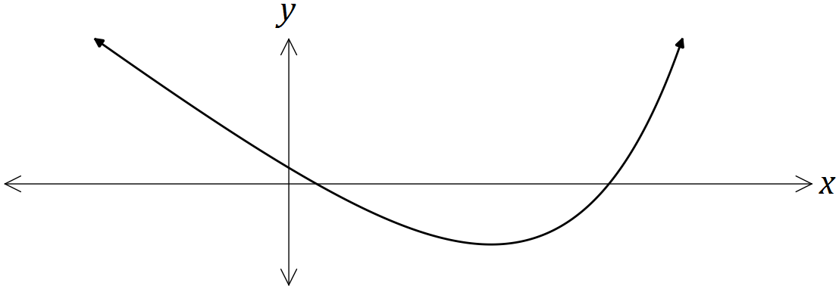

Determine the exact coordinates of the stationary point. (5 marks)
Solution
$$\frac{dy}{dx}=2e^{2x-1}-4 \\ \frac{dy}{dx}=0⇒e^{2x-1}=2 \\ 2x-1=\ln{2} \\ x=\frac{1}{2}+\frac{1}{2}\ln{2} \\ y=e^{\ln{2}}-4\left(\frac{1}{2}+\frac{1}{2}\ln{2} \right)=2-2-2\ln{2} \\ \text{Stationary point at }\left(\frac{1}{2}+\frac{1}{2}\ln{2}, -2\ln{2}\right)$$

Specific behaviours
obtains first derivative
equates to 0 and simplifies
takes logs of both sides
solves for $x$
substitutes to find $y$, simplifying

Question 6 (8 marks)
The diagram below shows the curve $y=x^{3}-3x^{2}+k$, where $k$ is a constant. The curve has a turning point on the $x$-axis.
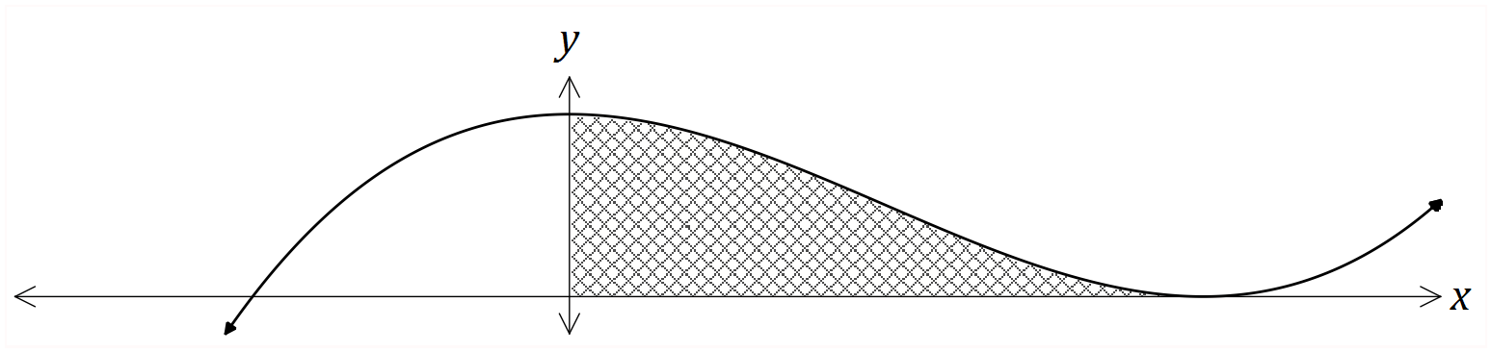

(a) Determine the value of $k$. (3 marks)
Solution
$$\frac{dy}{dx}=3x^{2}-6x \\ 3x\left(x-2\right)=0⇒x=0, x=2 \\ (2, 0)⇒8-12+k=0⇒k=4$$

Specific behaviours
differentiates
solves derivative equal to zero
determines $k$

(b) Determine the set of values of $x$ for which $\frac{dy}{dx}$ is increasing. (2 marks)
Solution
$$\frac{d^{2}y}{dx^{2}}=6x-6 \\ 6x-6=0⇒x=1⇒\frac{dy}{dx} \text{is increasing for }x>1$$

Specific behaviours
determines where 2nd derivative is zero
states inequality, not including 1

(c) Calculate the area of the shaded region. (3 marks)
Solution
$$A=\int_{0}^{2}{x^{3}-3x^{2}+4}dx \\ ={\left[\frac{x^{4}}{4}-x^{3}+4x\right]}_{0}^{2} \\ =4 \text{sq units}$$

Specific behaviours
writes integral
antidifferentiates
evaluates

Question 7 (8 marks)
The discrete random variable $X$ is defined by $P\left(X=x\right)=k\log{x}$ for $x=2, 5$ and $10$.

(a) Determine the value of $k$. (3 marks)

Solution
$$k\log{2}+k\log{5}+k\log{10}=1 \\ k\log\left(2×5×10\right)=1 \\ k=\frac{1}{\log{100}}=\frac{1}{2\log{10}}=\frac{1}{2}$$

Specific behaviours
substitutes and sums terms to 1
uses log laws to add logs
simplifies and states $k$

(b) Determine $P\left(X=2 \right| X<10)$. (2 marks)

Solution
$$P\left(X<10\right)=1-\frac{1}{2}\log{10}=\frac{1}{2} \\ P=\frac{1}{2}\log{2}÷\frac{1}{2}=\log{2}$$

Specific behaviours
calculates $P(X<10)$
calculates conditional probability

(c) $E\left(X\right)=a\left(b+\log{\sqrt{c}}\right)$, where the constants $a$, $b$ and $c$ are prime numbers. Determine the values of $a$, $b$ and $c$. (3 marks)

Solution
$$E\left(X\right)=2×\frac{1}{2}\log{2}+5×\frac{1}{2}\log{5}+10×\frac{1}{2}\log{10} \\ =\log{2}+\log{5}+\frac{3}{2}\log{5}+5 \\ =\log{10}+3\log{\sqrt{5}}+5 \\ =6+3\log{\sqrt{5}}=3\left(2+\log{\sqrt{5}}\right)$$

$$a=3, b=2, c=5$$

Specific behaviours
expresses $E\left(X\right)$
simplifies and splits $\log{5}$ term
simplifies to determine values of $a, b$ and $c$

Additional working space

Question number: _________

Additional working space

Question number: _________

© 2016 WA Exam Papers. Mercedes College has a non-exclusive licence to copy and communicate this paper for non-commercial, educational use within the school. No other copying, communication or use is permitted without the express written permission of WA Exam Papers.

